**Name: Dhruv Barot**

**Student id: 101415874**

**Course code- COMP3123**

**Postman Screenshot And mongo db Screenshot**

**Screenshot 01:-**

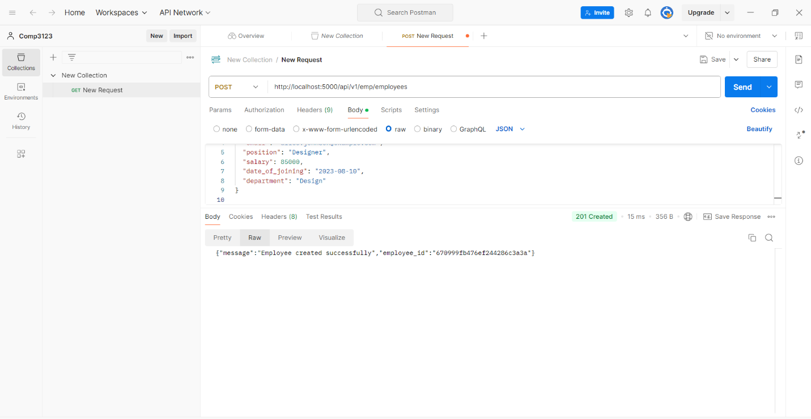

**Screenshot 02:-**

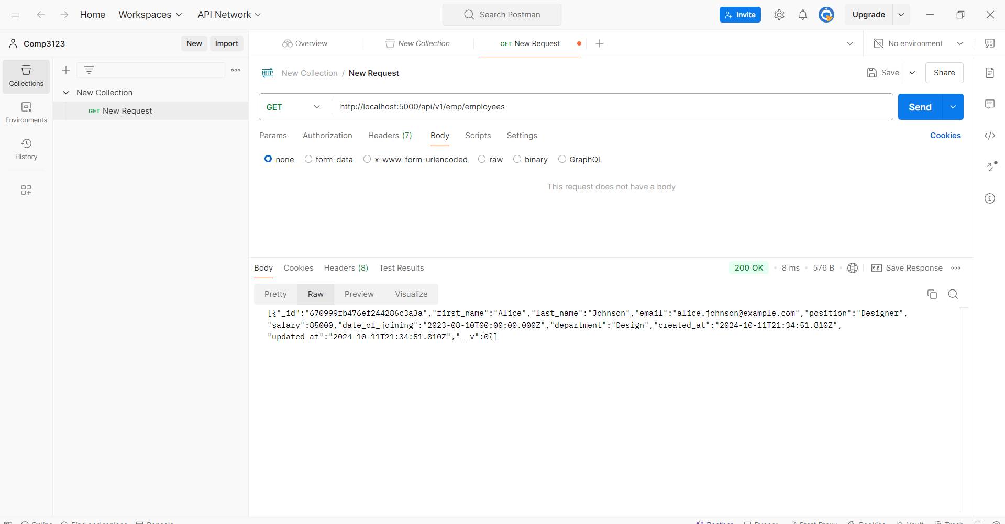

**Screenshot 03:-**

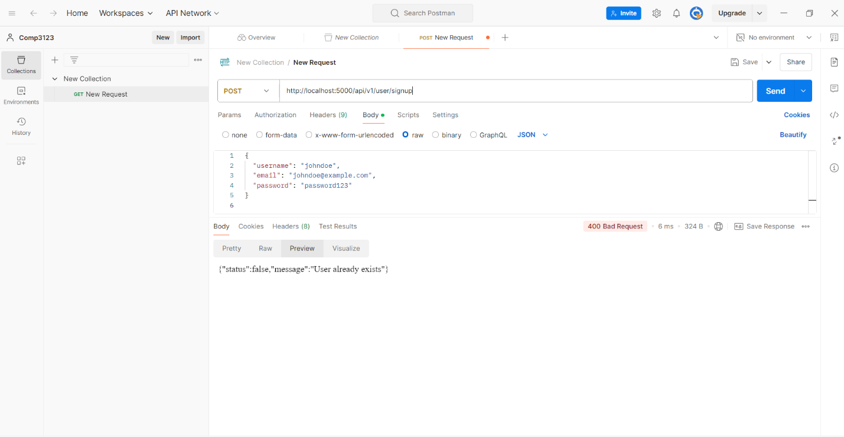

**Screenshot 04:-**

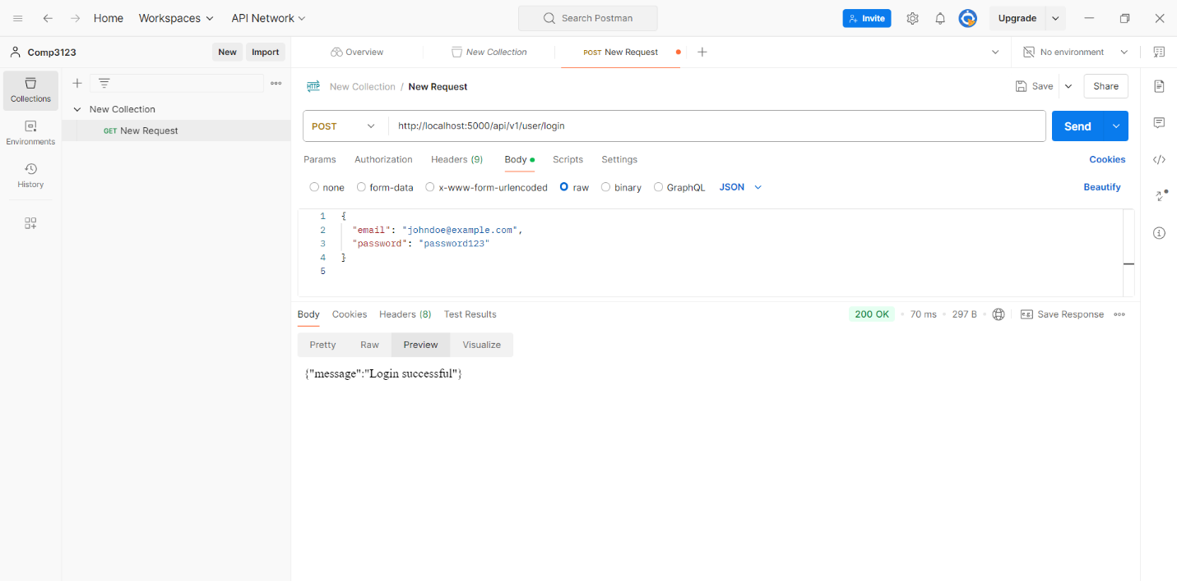

**Screenshot 05:-**

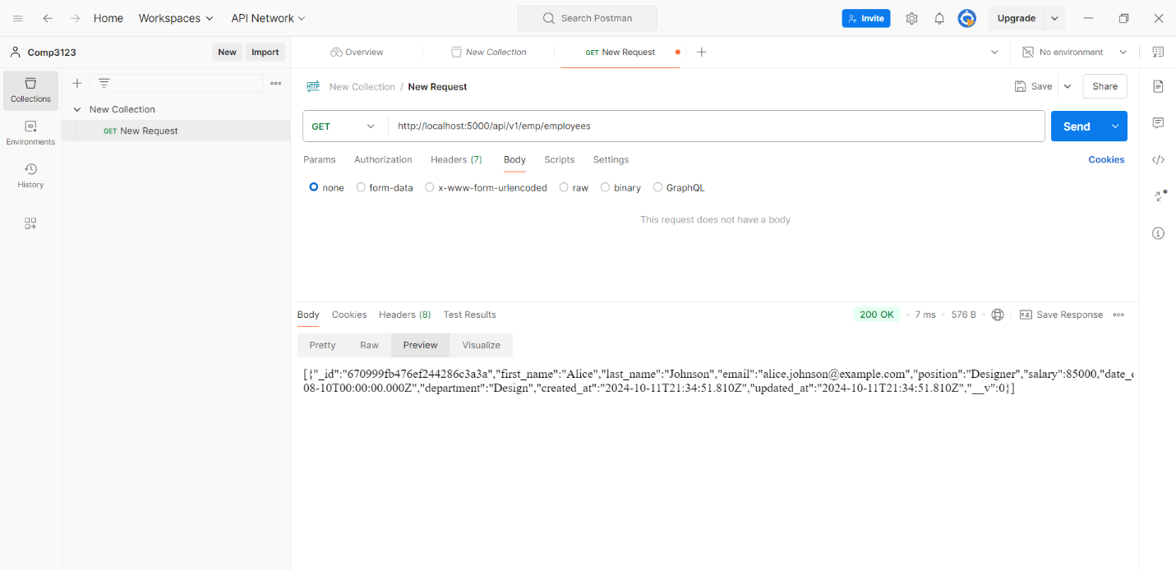

**Screenshot 06:-**

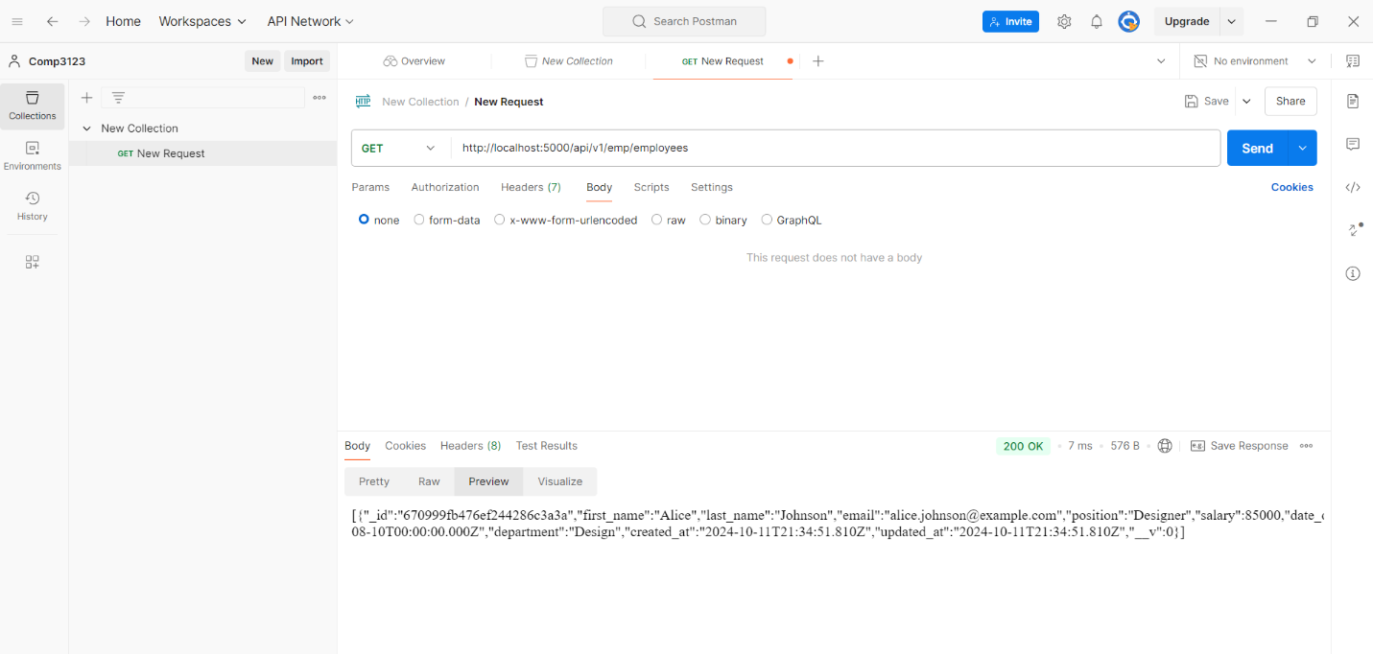

**Screenshot 07:-**

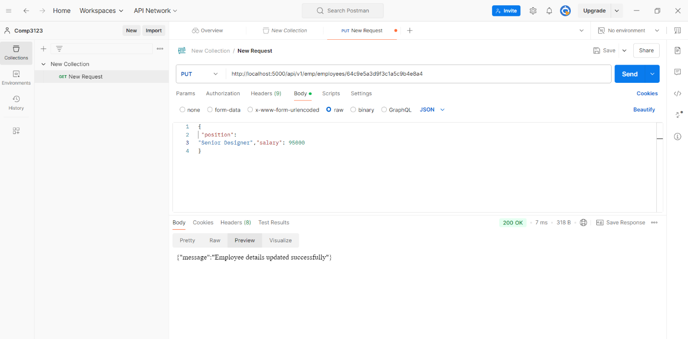

**Screenshot 08:-**

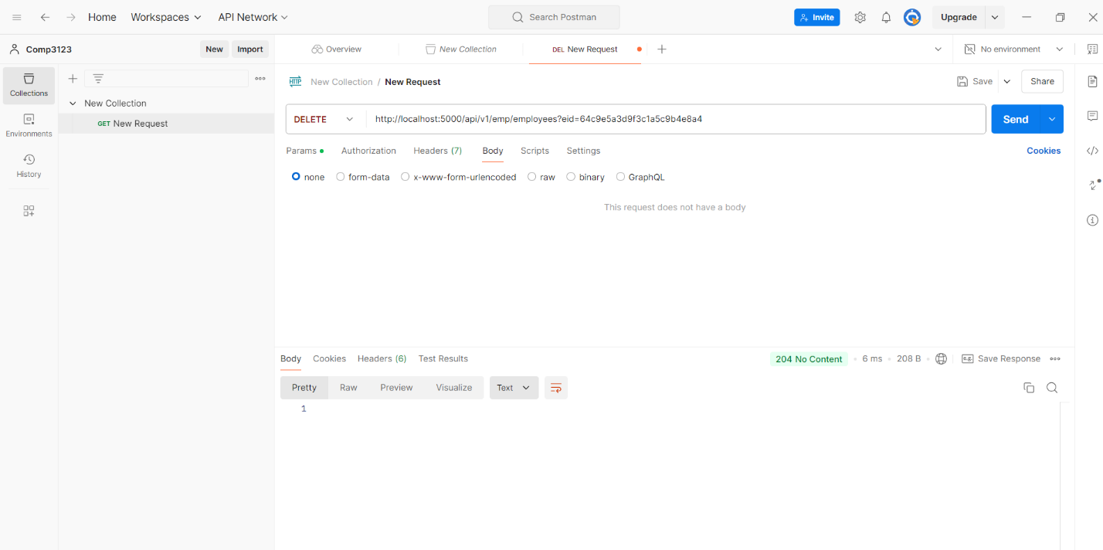

**Screenshot 09:-**

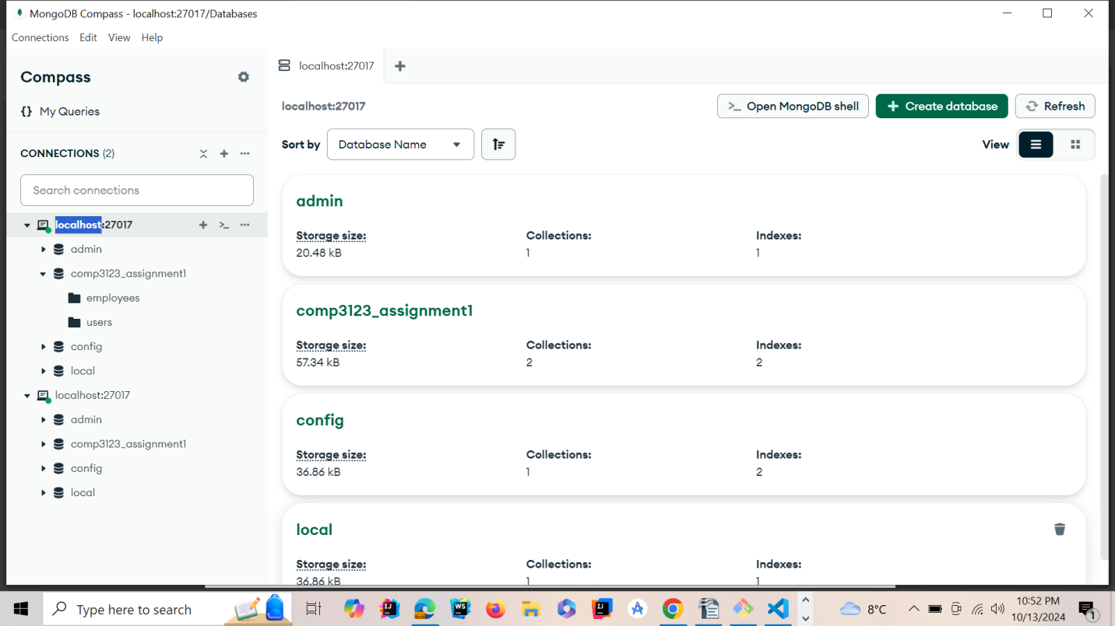

**Screenshot 10:**

